Williams Owens Olefin Plant Explosion - Thermodynamics
Impact of Incident: Two worker deaths and 167 injuries
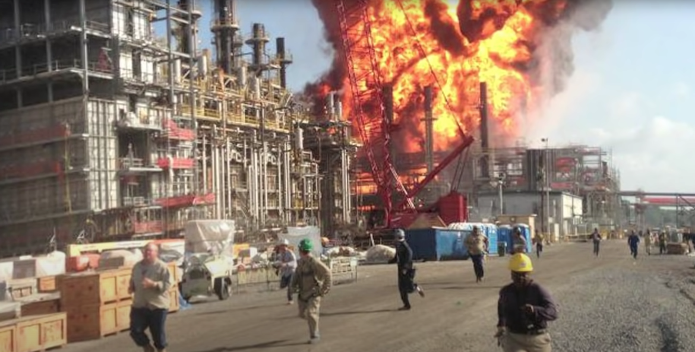
Image: Explosion at the Williams Owens Olefin Plant in Geismar, LA (source: csb.gov)
Williams Owens Olefin Plant Explosion - Thermodynamics 1
Problem Statement 2
Incident Information 2
Safety Analysis of the Incident 3
Calculations 4
Simulation 5
Chemical Hazard Analysis 9
Bow Tie Analysis 9
Reflection 9
Advanced Process Safety Modules 10
Hazard and Operability (HAZOP) Study 10
Layers of Protection Analysis (LOPA) 13
References 15
Definitions 16
General Process Safety Definitions 16
Module Specific to Williams Owens Olefin Plant Explosion 17
General Nomenclature 17
BLEVE Nomenclature 18

Problem Statement
Safety Module 2: Williams Owens Olefin Plant Explosion, June 13, 2013 in Geismar, LA
The Williams Owens Plant in Geismar, LA produces ethylene and propylene. The heat exchanger is attached to a fractionation column. Hot water on the tube side heats the propane and propylene on the shell side.
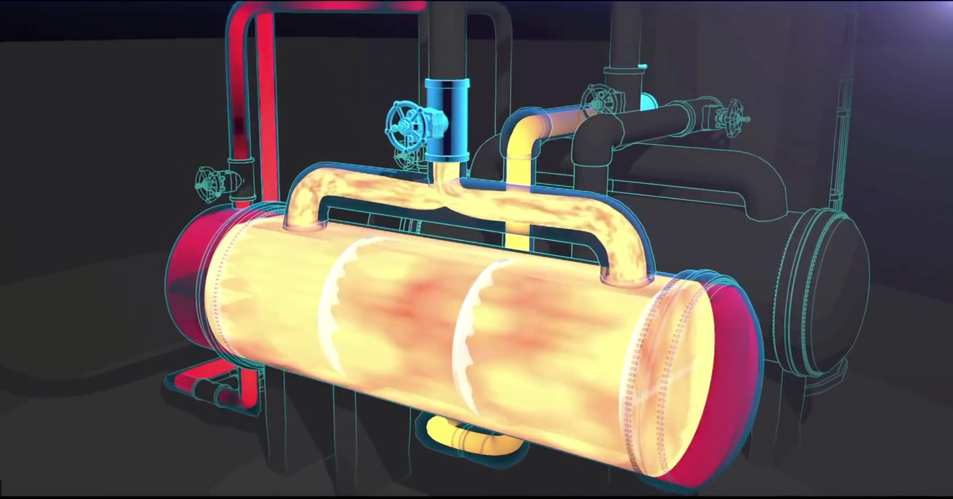
Image: Simulation of heat build-up in fouled propylene fractionator (source: csb.gov)
Workers understood that oily tar tended to build up on the inside of the reboiler tubes, requiring periodic shut down for cleaning. The plant manager observed a significant decrease in flow rate over the past day and attributed it to tar build up on the tube walls. Workers decided to switch to the stand-by exchanger, which had not been in use for 16 months. Unknown to workers, this stand-by heat exchanger was detached from its pressure relief valve and contained liquid propane. When hot water was introduced into this heat exchanger, it violently ruptured and exploded within three minutes. The incident killed two workers and injured 167.

Incident Information
CSB video about Williams Owens Olefin incident
CSB Williams Owens Olefin Incident Report pages 5, 9, 11, 14, 15, 56

Safety Analysis of the Incident
It is important that chemical engineers understand what the accident was, why it happened and how it could have been prevented in order ensure similar accidents may be prevented. Applying a safety algorithm to the accident will help achieve this goal. To become familiar with a strategy for accident awareness and prevention, view the Chemical Safety Board video on the Williams Owens Olefin plant explosion and fill out the following algorithm. See definitions on the last page. If necessary, view pages 5, 9, 11, 14, 15, and 56 of the CSB Williams Owens Olefin Incident Report.

Criteria | Responses
Activity
Hazard
Incident
Initiating Event
Preventative Actions and Safeguards
Contingency Plan and
Mitigating Actions
Lessons Learned

Calculations
The following calculation connects safety considerations within this module to knowledge learned in this course to help understand how your knowledge can minimize safety issues.
- Calculate the increase in pressure in the liquid propane shell side of the heat exchanger using the Clausius-Clapeyron equation when hot water flows through the tube side of the heat exchanger.

Simulation
Answer the following questions using Wolfram siders.
- Download Wolfram CDF Player for free. Instructions on how to install the player can be found on Wolfram’s support page.
  - Instructions for installing on Windows
  - Instructions for installing on MacOS
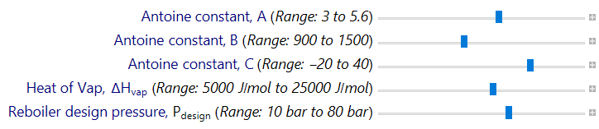
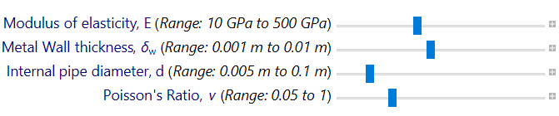
- Download Wolfram code for this module
Wolfram sliders

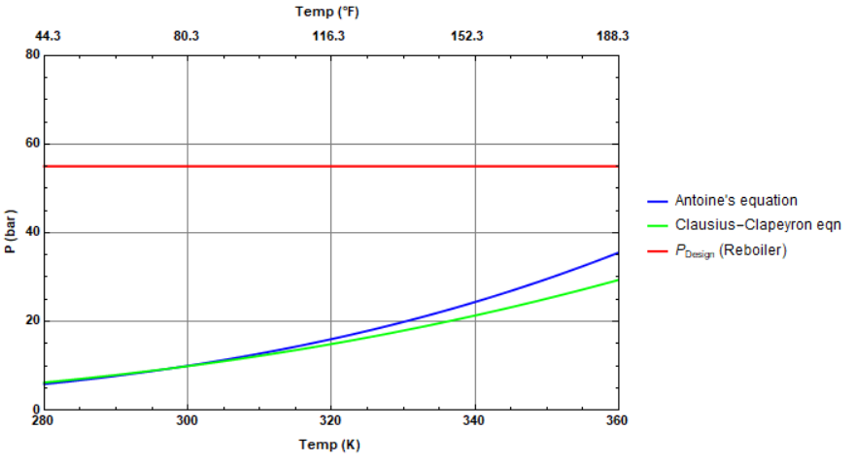
Sample output graph: Vapor pressure vs. temperature
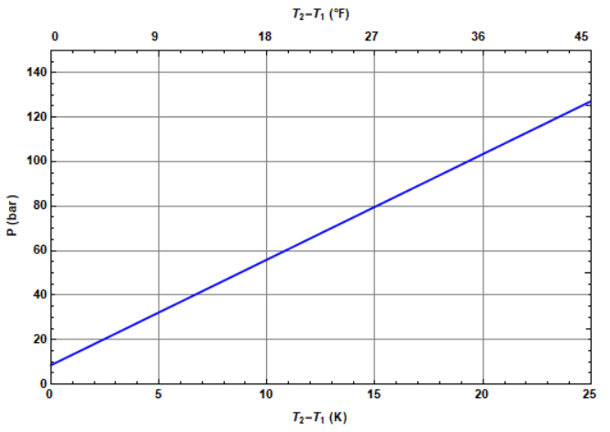
Sample output graph: Pressure inside reboiler vs. change in temperature (final-initial)

- One of the reasons for explosion could have been the over-pressurization of the heat exchanger due to the equilibrium vapor pressure at the quench water inlet temperature of 360 K. From the Wolfram plot, estimate the pressure that was exerted by propane vapor, using the Antoine Equation. Do you think that equilibrium vapor pressure was a major reason for the rupture? Assume the reboiler rupture pressure to be 55 bar.

- Describe how the vapor pressure obtained using the Clausius-Clapeyron Equation is different than that obtained using the Antoine equation? Find the value of ΔH_{vap} at which the pressures calculated using the Clausius-Clapeyron Equation and the Antoine Equation agree with each other (within 3%). Can you explain the discrepancy between the pressures calculated by the two equations?
Antoine Equation parameters for propane:
A=4.54
B=1149
C=24.9

- Use the following Antoine Equation parameters for butane: A = 4.35, B = 1175, C = -2.07. Comment on the differences between propane and butane and on the potential danger due to over-pressurization.

- Next consider the possibility of a boiling liquid expanding vapor explosion (BLEVE)¹. The expansion of the liquid with temperature can ultimately lead to over-pressurization and rupture of the container. From the Wolfram plot, find the BLEVE pressure buildup, and determine whether it exceeded the maximum pressure which the reboiler could handle. Is the BLEVE pressure buildup more or less than the pressure buildup due to heating of propane vapor? More information on BLEVE Nomenclature can be found in the Definitions.
Additional Information:
- Quench water temperature=360 K
- Ambient temperature=300 K
- Total volume available between closed valves=8.2 m³
- Density at ambient temperature = 495 kg/m³
- Density at Quench water inlet temperature = 324 kg/m³
The pressure buildup in the confined space inside the reboiler is due to the pressure rise due to simultaneous heating of the pipe and blocked-in liquid in the confined space of the container (BLEVE), and can be calculated using the following equation (CCPS² and Karcher³) :

- Vary parameters E, δw, d, ν on the sliders and observe how the pressure in the confined space inside the reboiler changes, and how the explosion could have been prevented.

- Write a set of conclusions based on your experiments in the previous questions.

Chemical Hazard Analysis
Review the information in the NFPA Diamond tutorial. After reviewing the information, visit the CAMEO Chemicals website and fill out the blank NFPA Diamond to the right for propane.
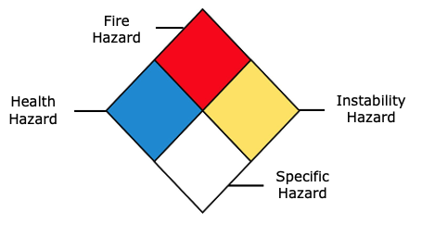
- Fire Hazard:
- Health Hazard:
- Instability Hazard:
- Specific Hazard:

Bow Tie Analysis
Review the Bow Tie diagram tutorial. After reviewing the information, create a Bow Tie diagram for the Williams Owen Olefin Plant incident.

Reflection
Describe what was the most unsettling to you about the incident.

Advanced Process Safety Modules
The next parts are based on industry practices used to assess process safety and are designed to be used in upper-level courses. For professors interested in assigning these parts now, tutorials for both can be found on the University of Michigan SAFEChE website.

Hazard and Operability (HAZOP) Study
A HAZOP study is a structured analysis of process design to identify potential vulnerabilities in a facility. Review the HAZOP tutorial before completing one for the following system. It is important to note that not all guidewords and parameters will be relevant for different systems. Some information is given here for guidance:
System to consider: Bottom part of fractionator column that includes the active reboiler (A) and stand-by reboiler (B). Hot quench water flows through the tube side of the reboiler while propane flows through the shell side of the reboiler. Car seals were used to lock open the outlet valve of the process fluid when the reboiler is in operation. It is also assumed that the standard operating procedure used while switching from the operating reboiler to the standby reboiler is first opening the quench water, and then opening the process fluid valve.
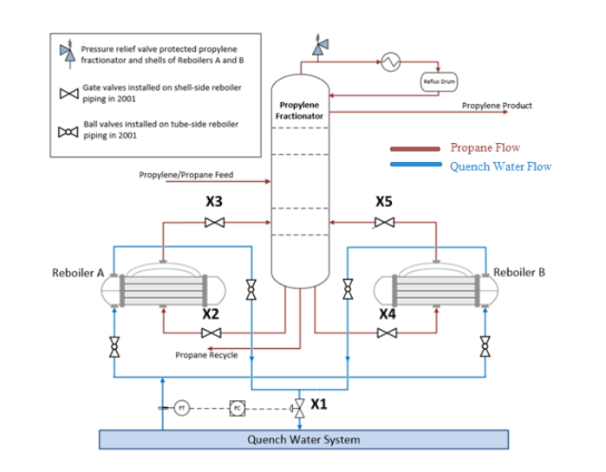
Process Parameters to Consider: Temperature, Pressure, Flow of process fluid, Flow of quench water, Start-up
- Fill out the HAZOP chart as shown in the tutorial. Some information has been filled out here for you.
Guideword + Parameter = Deviation | Causes | Consequences | Safeguards | Recommendations
More Flow of Quench Water into Reboiler A

No/Less Flow of Process Fluid into Reboiler A | Closure of valve X2 due to human error
More (High) Temperature of the process fluid in the shell side of Reboiler A | Closure of the outlet valve X3 isolating the reboiler from the only pressure safety valve
More (High) Pressure in Reboiler A

Other (Start-Up) of Reboiler B | Fouling in the operating reboiler

- When conducting a HAZOP, you will often find combinations of guidewords and parameters that describe a possible situation for the system that is not hazardous. For the given process parameters, give an example, explain why the situation is not hazardous, and describe another consequence that could occur. HINT: Consider process efficiency

- Write a short conclusion on some takeaways from completing a HAZOP for this system and recommendations you would make.

Layers of Protection Analysis (LOPA)
A Layers of Protection Analysis (LOPA) is a semi-quantitative study to identify available safeguards and determine if the safeguards sufficiently protect against a given risk. Review the LOPA tutorial before filling the table out for the system described in this module. Some information is given for guidance:
- Assume that the plant can only accept a moderate risk
- Assume that the reboilers undergo maintenance once per year
- The explosion caused 2 fatalities and injured many more

LOPA Study for William Owens Explosion
Initiating Event | Cause: | Operator Error (Followed incorrect procedure while switching reboilers)
 | Consequence: | Increase in Pressure inside the reboiler leading to an explosion
 | Frequency of Initiating Event (FOIE):
Independent Protection Layers (IPLs) | Description of IPL₁, IPL₂ ...
Probability of Failure of IPLs:
PFD = PFD1 x PFD2 x ...
Mitigated consequence frequency (MCF) | MCF = FOIE x PFD
 | Category of MCF:
Severity | Impact: | Multiple fatalities
 | Category:
Risk | Type of risk:
 | Acceptable / Unacceptable?

If risk evaluated above is unacceptable, please continue below:
Proposed IPL(s)  (P-IPL(s)) | Description of P-IPL₁, P-IPL₂, ...
 | P-PFD = P-PFD₁ x P-PFD₂ x ...
MCF | MCF = FOIE x PFD x P-PFD
 | Category of MCF:
Risk | Type of risk:
 | Acceptable / Unacceptable?

References
- https://inspectapedia.com/plumbing/BLEVE-Explosions.php
- CCPS, Guidelines for pressure relief and effluent handling systems, 1998, ISBN 0-8169-0476-6
- G.C Karcher, Pressure changes in liquid filled vessels or piping due to temperature changes, ExxonMobil Research and Engineering Mechanical Newsletter EE.84E.76 , August 1976
- Crowl, D. A. and J.F. Louvar, Chemical Process Safety with Applications, Prentice Hall, Upper Saddle River, NJ.

Definitions

General Process Safety Definitions
Term | Definition
Activity | The process, situation, or activity for which risk to people, property or the environment is being evaluated.
Hazard | A chemical or physical characteristic that has the potential to cause damage to people, property, or the environment.
Incident | What happened? Description of the event or sum of the events along with the steps that lead to one or more undesirable consequences, such as harm to people, damage to property, harm to the environment, or asset/business losses.
Initiating Event | The event that triggers the incident, (e.g., failure of equipment, instrumentation, human actions, flammable release, etc.). Could also include precursor events, (e.g., no flow from pump, valve closed, inadvertent human action, ignition). The root cause of the sum events in causing the incident.
Preventative Actions and Safeguards | Steps that can be taken to prevent the initiating event from occurring and becoming an incident that causes damage to people, property, or the environment. Brainstorm all problems that could go wrong and then actions that could be taken to prevent them from occurring.
Contingency Plan/ Mitigating Actions | These actions occur after the initiating event. They are steps that reduce or mitigate the incident after the preventative action fails and the initiating event occurred.
Lessons Learned | What we have learned and can pass on to others that can prevent similar incidents from occurring
Bow Tie Diagram | A qualitative hazard analysis tool through which potential problems and consequences associated with a hazard are studied through a pictorial representation. Necessary preventive and mitigating barriers are determined to reduce the process safety risk.
Hazard and Operability Study (HAZOP) | A qualitative hazard analysis tool that uses a set of guide words to determine whether deviations from design or operating intent can lead to undesirable consequences. The existing safeguards are evaluated and if required, actions are recommended to mitigate the consequences.
Layer of Protection Analysis (LOPA) | A semi-quantitative study that determines initiating event frequency, consequence severity, and likelihood of failure of independent protection layers (IPLs) to calculate the risk of a scenario. If the existing risk is intolerable, then additional IPLs are suggested to bring down risk to an acceptable level.

Module Specific to Williams Owens Olefin Plant Explosion
Term | Definition
Fouling | The accumulation of unwanted material on solid surfaces to the detriment of function
Boiling Liquid Expanding Vapor Explosion (BLEVE)⁴ | A BLEVE occurs when a vessel containing a liquid at a temperature above its atmospheric boiling point ruptures. The subsequent BLEVE is an explosive vaporization of a large fraction of the vessel contents that can be followed by combustion or explosion of the vaporized cloud. BLEVE occurs when an external heat source heats the contents of the vessel thereby increasing the vapor pressure in the vessel and reducing its structural integrity.

General Nomenclature
Symbol | Description | SI Unit
P^{sat} | Saturation pressure | bar
ΔH_{vap} | Enthalpy of vaporization | kJ/mol

BLEVE Nomenclature
Symbol | Description | SI Unit
P₂ | final gauge pressure of blocked-in, liquid-full equipment | kPa
P₁ | initial gauge pressure of blocked-in, liquid-full equipment=854.95 kPa (vapor pressure of liquid at ambient temp) | kPa
T₂ | maximum temperature of blocked-in, liquid-full equipment=311 K (At this temperature, the reboiler exploded due to over-pressurization) | K
T₁ | initial temperature of blocked-in, liquid-full equipment=300 K | K
α_{v} | cubic expansion coefficient of the liquid=0.003 /K | 1/K
α| | linear expansion coefficient of metal wall=13*10⁻⁶ /K | 1/K
χ | isothermal compressibility coefficient of the liquid=6.22 *10⁻⁹/Pa | 1/Pa
d | internal pipe diameter, expressed in inches=0.01905m | m
E | modulus of elasticity for the metal wall at T₂, expressed in psi=200 GPa | GPa
δ_{w} | metal wall thickness of tube, expressed in inches=0.00508 m | m
ν | Poisson’s ratio= 0.3

