Praxair Cylinder Explosion and Fire - Thermodynamics
Impact of Incident: One death of a community member due to vapor inhalation, extensive facility damage, damage to surrounding community property (cars, residential and commercial buildings)
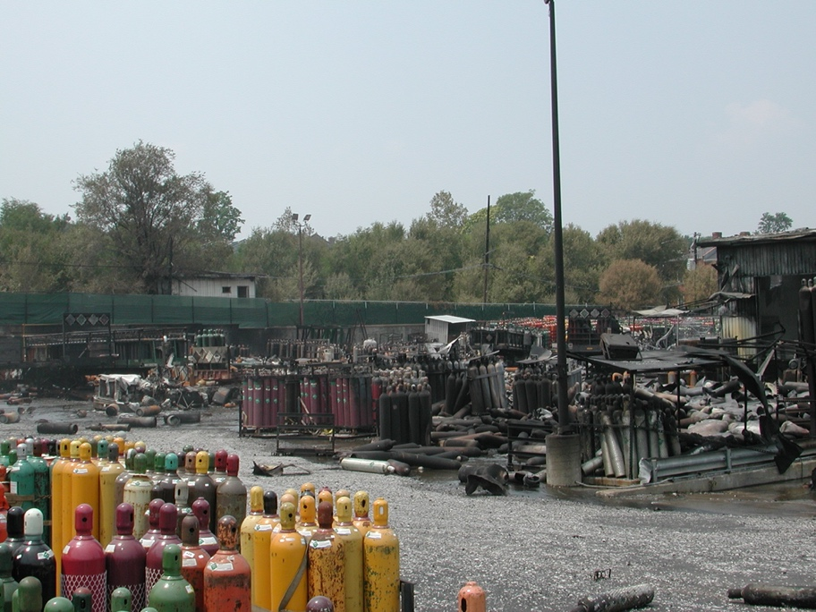

Image: Aftermath of the St. Louis, MO Praxair facility (source: csb.gov)
Praxair Cylinder Explosion and Fire - Thermodynamics 1
Problem Statement 2
Incident Information 2
Safety Analysis 3
Calculations 4
Simulation 5
Chemical Hazard Analysis 7
Bow Tie Analysis 7
Reflection 7
Advanced Process Safety Modules 8
Hazard and Operability (HAZOP) Study 8
Layers of Protection Analysis (LOPA) 10
References 12
Definitions 13
General Process Safety Definitions 13
Module Specific to Praxair Fire and Explosion 14
General Nomenclature 14

Problem Statement
Safety Module 1: Praxair Flammable Gas Cylinder Explosion, June 24, 2005, in St. Louis, MO. Developed in collaboration with Kara Steshetz, University of Michigan and Professor Andrej Lenert, University of Michigan
It was a hot day in St. Louis, 96°F (35.9°C), where Praxair had set cylinders with flammable gases on hot black asphalt pavement. Direct sunlight and radiant heat from the asphalt pavement¹ heated the propylene cylinders.
The vapor pressure in a liquid propylene cylinder exceeded a faulty set pressure on the cylinder’s relief valve that was too low, and propylene escaped into the yard. The resulting vapor plume found an ignition source and a fire started. The fire heated nearby acetylene and liquefied petroleum gas (LPG) cylinders and they in turn released more flammable gases, which enlarged the fire.
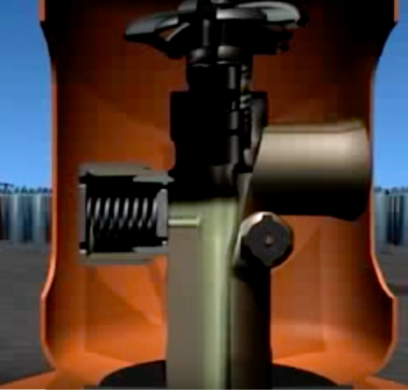
Image: Cut away of a pressure relief valve (source: csb.gov)

Incident Information
CSB video about Praxair incident
CSB Praxair Incident Report pages 1-10

Safety Analysis
It is important that chemical engineers understand what the accident was, why it happened and how it could have been prevented in order ensure similar accidents may be prevented. Applying a safety algorithm to the accident will help achieve this goal. To become familiar with a strategy for accident awareness and prevention, view the Chemical Safety Board video on the Praxair flammable gas fires and explosion and fill out the following algorithm. See definitions on the last page. If necessary, view pages 1-10 of the Praxair incident report.
Criteria | Responses
Activity
Hazard
Incident
Initiating Event
Preventative Actions and Safeguards
Contingency Plan and
Mitigating Actions
Lessons Learned

Calculations
The following calculations connect safety considerations within this module to knowledge learned in this course to help understand how your knowledge can minimize safety issues.
On the day of the explosion, the air temperature reached 97°F (36°C) at 2 p.m. and the asphalt surface was approximately 140°F (333 K) causing the cylinder temperature to be at least 135°F (330 K).
Additional information:
- Propylene boils at 225.6K at 1 atm (101.3 kPa)
- The heat of vaporization is $18.4\frac{kJ}{mol}$
- R = $8.314\frac{J}{mol K}$
- The critical pressure and temperature are P_{C} = 4.6 ΜPa and T_{C} = 364.9 K respectively
- The vapor molar volume of propylene is $2.13∙{10}^{-3}\frac{m^{3}}{mol}$
- Use the ideal gas law to estimate the pressure, P, inside the cylinder at 25°C and at 57°C (330 K) when there is only propylene gas.

- Assuming vapor liquid equilibrium estimate the pressure, P, in the cylinder at 25°C and at 57°C using:
- The Clausius-Clapeyron equation
$$P_{2}=P_{1}exp\left[\frac{-∆H_{vap}}{R}\left(\frac{1}{T_{2}}-\frac{1}{T_{1}}\right)\right]⁡$$

- The short cut equation.
$$\log_{10}⁡\left(\frac{P}{P_{C}}\right)=\frac{7}{3}\left(ω+1\right)\left(1-\frac{T_{C}}{T}\right)$$
Where ω is the acentric factor^{2,3} with ω = 0.142 for propylene⁴.

- Plot Pressure, P, as a function of Temperature, T, using the ideal gas law, the Clausius-Clapeyron equation, and the short cut equation from 25°C to 67°C on the same figure and then write a conclusion.

Simulation
Answer the following questions using Wolfram siders.
- Download Wolfram CDF Player for free. Instructions on how to install the player can be found on Wolfram’s support page.
  - Instructions for installing on Windows
  - Instructions for installing on MacOS
- Download Wolfram code for this module

Wolfram sliders
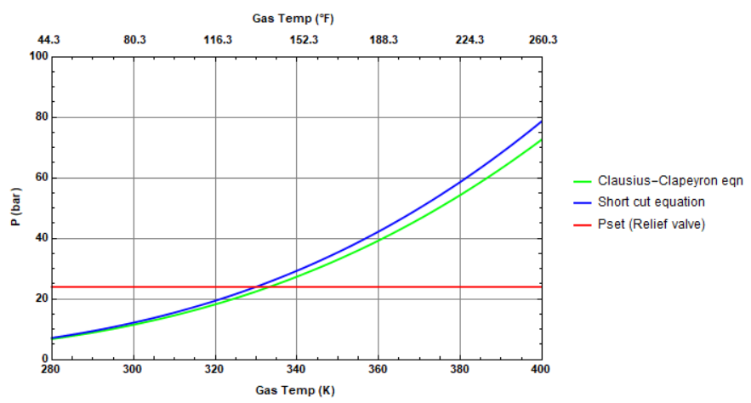
Sample output graph: Vapor pressure vs. temperature
- Refer to the Wolfram plot of vapor pressure vs. temperature obtained using the shortcut equation. Find the minimum set pressure such that the explosion could have been prevented. Assume that the explosion occurred at a temperature of 135°F (330 K). Vary the slider for set pressure and describe how maximum allowable temperature varies with increasing set pressure.

- What is the required set pressure if you use the Clausius Clapeyron Equation with ΔH_{vap}=15 kJ/mol? Is this set pressure more or less than that obtained in (a). Vary the ΔH_{vap} slider to check at what value of ΔH_{vap} the Clausius Clapeyron Equation agrees with the shortcut equation (within 3%). Can you explain the discrepancy between the pressures calculated by the two equations?

- Describe how the vapor pressure – temperature curve (for shortcut equation) changes when propane is changed to butane or ethane. Vary the sliders for P_{set} and describe what you find. Are there any generalizations that you can make? Keep in mind that the Wolfram plot is generic and shows entire temperature range, but the curves for different substances will not be valid past their critical temperature.
Shortcut Equation Parameters
Component | Critical Temperature (K) | Critical Pressure (bar) | Acentric Factor
Ethane | 305.4 | 48.8 | 0.099
Butane | 425.2 | 38.0 | 0.199

- Write a set of conclusions based on your experiments (a) through (c).

Chemical Hazard Analysis
Review the information in the NFPA Diamond tutorial. After reviewing the information, visit the CAMEO Chemicals website and fill out the blank NFPA Diamond below for propylene.
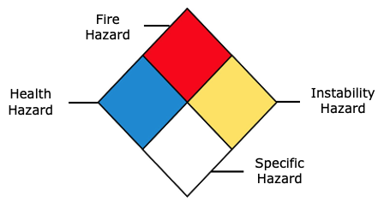
- Fire Hazard:
- Health Hazard:
- Instability Hazard:
- Specific Hazard:

Bow Tie Analysis
Review the Bow Tie diagram tutorial. After reviewing the information, create a Bow Tie diagram for the Praxair incident.

Reflection
Describe what was the most unsettling to you about the incident.

Advanced Process Safety Modules
The next parts are based on industry practices used to assess process safety and are designed to be used in upper-level courses. For professors interested in assigning these parts now, tutorials for both can be found on the University of Michigan SAFEChE website.

Hazard and Operability (HAZOP) Study
A HAZOP study is a structured analysis of process design to identify potential vulnerabilities in a facility. Review the HAZOP tutorial before completing one for the following system. It is important to note that not all guidewords and parameters will be relevant for different systems. Some information is given here for guidance:
System to consider: Praxair cylinder filled with propylene in vapor-liquid equilibrium
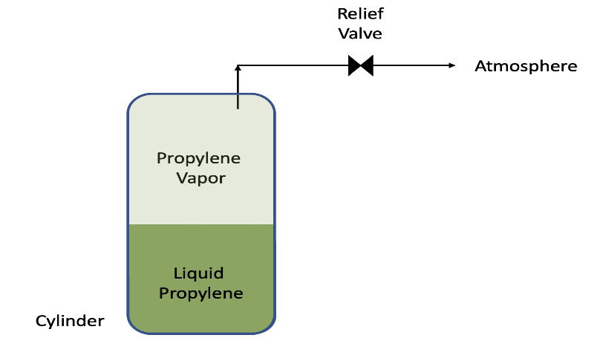
Process Parameters to Consider: Temperature, Pressure
- Fill out the HAZOP chart as shown in the tutorial. In this case, the consequences, safeguards, and recommendations will be the same for both deviations.

Guideword + Parameter = Deviation | Causes | Consequences | Safeguards | Recommendations
More (Higher) Temperature

More (Higher) Pressure | Increase of temperature in cylinder
- When conducting a HAZOP, you will often find combinations of guidewords and parameters that describe a possible situation for the system that is not hazardous. For the given process parameters, give an example and explain why the situation is not hazardous.

- Write a short conclusion on some takeaways from completing a HAZOP for this system and recommendations you would make.

Layers of Protection Analysis (LOPA)
A Layers of Protection Analysis (LOPA) is a semi-quantitative study to identify available safeguards and determine if the safeguards sufficiently protect against a given risk. Review the LOPA tutorial before filling the table out for the system described in this module. Some information is given for guidance:
- Assume that the plant can only accept a minor risk
- The fire destroyed many cylinders and tanks, resulting in business losses of more than $100,000. Flying cylinders created the potential for severe injuries
- The ultimate cause of the incident was the heat wave, which can be expected to occur 1 time every year in St. Louis
LOPA Study for Praxair Fire and Explosion
Initiating Event | Cause: | Heat wave
 | Consequence: | Release of propylene vapor due to high pressure in cylinder and potential for ignition and explosion
 | Frequency of Initiating Event (FOIE):
Independent Protection Layers (IPLs) | Description of IPL₁, IPL₂ ...
Probability of Failure of IPLs:
PFD = PFD1 x PFD2 x ...
Mitigated consequence frequency (MCF) | MCF = FOIE x PFD
 | Category of MCF:
Severity | Impact: | Potential for severe injury and some business losses
 | Category:
Risk | Type of risk:
 | Acceptable / Unacceptable?

If risk evaluated above is unacceptable, please continue below:
Proposed IPL(s)  (P-IPL(s)) | Description of P-IPL₁, P-IPL₂, ...
 | P-PFD = P-PFD₁ x P-PFD₂ x ...
MCF | MCF = FOIE x PFD x P-PFD
 | Category of MCF:
Risk | Type of risk:
 | Acceptable / Unacceptable?

References
- Katharine K. Guan, “Surface and ambient air temperatures associated with different ground material: a case study at the University of California, Berkeley, “Surface and Air Temperatures of Ground Material Spring 2011.310
- Dahm, K.D. and D. P. Visco, Fundamentals of Chemical Engineering Thermodynamics, p.311, Cengage Learning, Stamford, CT (2015).
- Matsoukas, T., Fundamentals of Chemical Engineering Thermodynamics with Applications to Chemical Processes, p.49, Prentice Hall, Upper Saddle River, NJ (2013).
- NIST Webbook: Propylene properties. https://webbook.nist.gov/cgi/cbook.cgi?ID=C115071&Mask=4

Definitions

General Process Safety Definitions
Term | Definition
Activity | The process, situation, or activity for which risk to people, property or the environment is being evaluated.
Hazard | A chemical or physical characteristic that has the potential to cause damage to people, property, or the environment.
Incident | What happened? Description of the event or sum of the events along with the steps that lead to one or more undesirable consequences, such as harm to people, damage to property, harm to the environment, or asset/business losses.
Initiating Event | The event that triggers the incident, (e.g., failure of equipment, instrumentation, human actions, flammable release, etc.). Could also include precursor events, (e.g., no flow from pump, valve closed, inadvertent human action, ignition). The root cause of the sum events in causing the incident.
Preventative Actions and Safeguards | Steps that can be taken to prevent the initiating event from occurring and becoming an incident that causes damage to people, property, or the environment. Brainstorm all problems that could go wrong and then actions that could be taken to prevent them from occurring.
Contingency Plan/ Mitigating Actions | These actions occur after the initiating event. They are steps that reduce or mitigate the incident after the preventative action fails and the initiating event occurred.
Lessons Learned | What we have learned and can pass on to others that can prevent similar incidents from occurring
Bow Tie Diagram | A qualitative hazard analysis tool through which potential problems and consequences associated with a hazard are studied through a pictorial representation. Necessary preventive and mitigating barriers are determined to reduce the process safety risk.
Hazard and Operability Study (HAZOP) | A qualitative hazard analysis tool that uses a set of guide words to determine whether deviations from design or operating intent can lead to undesirable consequences. The existing safeguards are evaluated and if required, actions are recommended to mitigate the consequences.
Layer of Protection Analysis (LOPA) | A semi-quantitative study that determines initiating event frequency, consequence severity, and likelihood of failure of independent protection layers (IPLs) to calculate the risk of a scenario. If the existing risk is intolerable, then additional IPLs are suggested to bring down risk to an acceptable level.

Module Specific to Praxair Fire and Explosion
Term | Definition
Set Pressure | Pressure at which a relief valve begins to open
Relief Valve | A spring-operated valve designed to prevent damage to equipment due to high pressure

General Nomenclature
Symbol | Description | SI Unit
T_{c} | Critical temperature | K
P_{c} | Critical pressure | bar
ω | Acentric factor | ---
ΔH_{vap} | Enthalpy of vaporization | kJ/mol

