Acetone Drum Explosion - Material & Energy Balances
Impact of Incident: One worker fatality
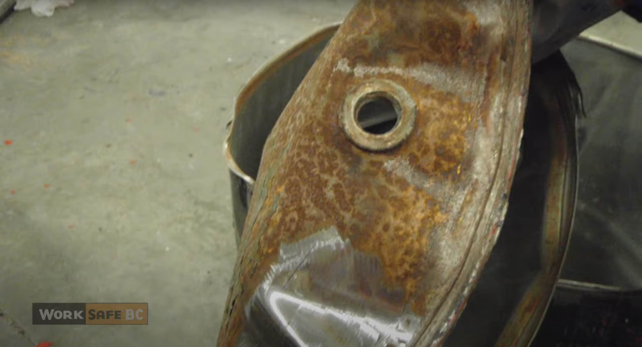
Image: The remains of an exploded drum (source: WorkSafeBC)
Acetone Drum Explosion - Material & Energy Balances 1
Problem Statement 2
Incident Information 2
Safety Analysis 3
Calculations 4
Simulation 5
Chemical Hazard Analysis 7
Bow Tie Analysis 7
Reflection 7
Advanced Process Safety Modules 8
Hazard and Operability (HAZOP) Study 8
Definitions 10
General Process Safety Definitions 10
Module Specific Definitions for Acetone Drum Explosion 11
General Nomenclature 11

Problem Statement
Safety Module 2: Acetone Drum Explosion During Welding. Developed in collaboration with Kara Steshetz, University of Michigan and Professor Bryan Goldsmith, University of Michigan.
A worker was welding on an empty acetone drum to attach casters to make a shop cart. The drum was rinsed with water and inverted, and the worker began welding. It was estimated that the equivalent of one tablespoon of acetone remained trapped in the crevices of the drum. The welding flame broke through the bottom of the inverted drum and there was an explosion killing the welder.
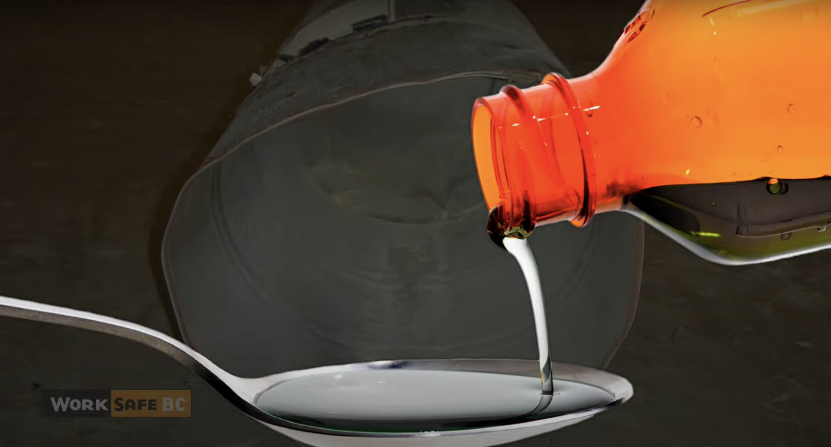
Image: A tablespoon of acetone (Source:WorkSafeBC)

Incident Information
Video about Acetone Drum Explosion

Safety Analysis
It is important that chemical engineers understand what the accident was, why it happened, and how it could have been prevented to ensure similar accidents may be prevented. Performing a safety analysis to the accident will help achieve this goal. In order to become familiar with a strategy for accident awareness and prevention, view the YouTube video made by WorkSafeBC on the drum explosion during welding and fill out the safety analysis table below. See definitions on the last page.

Criteria | Responses
Activity
Hazard
Incident
Initiating Event
Preventative Actions and Safeguards
Contingency Plan and
Mitigating Actions
Lessons Learned

Calculations
The following calculations connect safety considerations within this module to knowledge learned in this course to help understand how your knowledge can minimize safety issues.

- Assuming the equivalent of 1 tablespoon of acetone was left on the sides of the inverted 44-gallon drum, calculate the concentration (in mole%) of acetone in vapor space of the inverted drum. Assume T = 300 K, and acetone is in the vapor phase.

- The LFL for acetone is 2.6 mole% and the UFL is 12.8 mole%. Assume any liquid acetone that evaporates spreads uniformly throughout the tank. Is it possible for the average gas-phase composition in the tank to be within the explosive limits at any time? Explain.

- Calculate the energy released (in grams of TNT equivalent) from a tablespoon of acetone, given that the molar enthalpy of TNT is -3410 kJ/mol.

- Assume the inverted 44-gallon drum was fully saturated with acetone at T = 300 K and 1 atm. Calculate the concentration in mole% of acetone in the vapor space of the inverted drum. Could the drum still combust?

Simulation
Answer the following questions using Wolfram siders.
- Download Wolfram CDF Player for free. Instructions on how to install the player can be found on Wolfram’s support page.
  - Instructions for installing on Windows
  - Instructions for installing on MacOS
- Download Wolfram code for this module

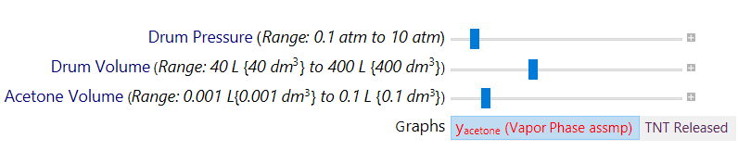
Wolfram sliders. Note: Here, the y_{acetone} in red represents acetone mole fraction for the case when the vapor phase is not assumed to be saturated with acetone vapors.

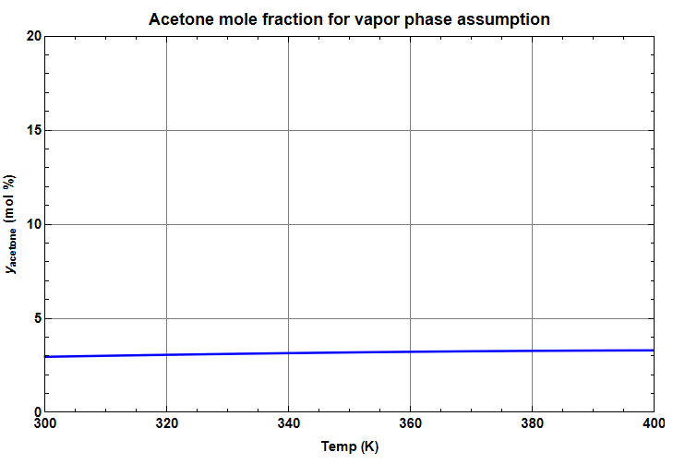
Sample output graph: Acetone mole fraction in drum assuming vapor phase as a function of temperature (K).

To calculate acetone density at different temp, we have used below correlation:
$$a=1-{T(K)}/{507.803};$$
$$b=1+a^{0.254167};$$
$ρ (kg/m^{3})={57.6214}/{(0.233955^b)}$
- Vary the slider for acetone volume and use the flammability limits to estimate the acetone volume permissible inside the drum that would not cause an explosion during welding, given that the surrounding pressure conditions are ambient.
Given: LFL of Acetone = 2.6 mol %
UFL of Acetone = 12.8 mol %

- Estimate the energy release (in grams of TNT) from acetone combustion at the lower and upper flammability limits.

- Vary the sliders and write a set of conclusions based on your experiments in the previous questions.

Chemical Hazard Analysis
Review the information in the NFPA Diamond tutorial. After reviewing the information, visit the CAMEO Chemicals website and fill out the blank NFPA Diamond below for acetone.
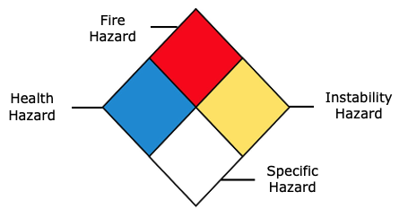
- Fire Hazard:
- Health Hazard:
- Instability Hazard:
- Specific Hazard:

Bow Tie Analysis
Review the Bow Tie diagram tutorial. After reviewing the information, create a Bow Tie diagram for the Praxair incident.

Reflection
Describe what was the most unsettling to you about the incident.

Advanced Process Safety Modules
The next part is based on industry practices used to assess process safety and are designed to be used in upper-level courses. For professors interested in assigning these parts now, a tutorial can be found on the University of Michigan SAFEChE website.

Hazard and Operability (HAZOP) Study
A HAZOP study is a structured analysis of process design to identify potential vulnerabilities in a facility. Review the HAZOP tutorial before completing one for the following system. It is important to note that not all guidewords and parameters will be relevant for different systems. Some information is given here for guidance:
System to consider: Drum that was previously used to store acetone
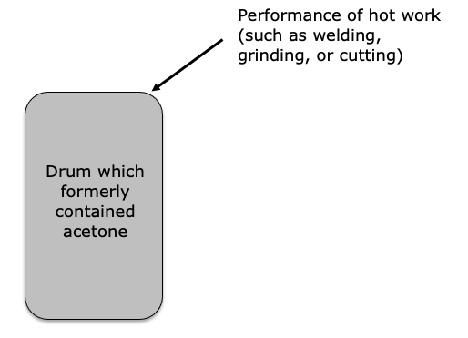
Process parameters to consider: Concentration, Temperature

- Fill out the HAZOP chart below. The first row has been filled out here for you as an example.
Guideword + Parameter = Deviation | Causes | Consequences | Safeguards | Recommendations
Other (Residual) Concentration of Acetone in the Drum |  |  | Warnings on drum
More (Higher) Temperature | Performance of hot work on the drum causing it to heat up
- Write a short conclusion on some takeaways from completing a HAZOP for this system and recommendations you would make.

Definitions

General Process Safety Definitions
Term | Definition
Activity | The process, situation, or activity for which risk to people, property or the environment is being evaluated.
Hazard | A chemical or physical characteristic that has the potential to cause damage to people, property, or the environment.
Incident | What happened? Description of the event or sum of the events along with the steps that lead to one or more undesirable consequences, such as harm to people, damage to property, harm to the environment, or asset/business losses.
Initiating Event | The event that triggers the incident, (e.g., failure of equipment, instrumentation, human actions, flammable release, etc.). Could also include precursor events, (e.g., no flow from pump, valve closed, inadvertent human action, ignition). The root cause of the sum events in causing the incident.
Preventative Actions and Safeguards | Steps that can be taken to prevent the initiating event from occurring and becoming an incident that causes damage to people, property, or the environment. Brainstorm all problems that could go wrong and then actions that could be taken to prevent them from occurring.
Contingency Plan/ Mitigating Actions | These actions occur after the initiating event. They are steps that reduce or mitigate the incident after the preventative action fails and the initiating event occurred.
Lessons Learned | What we have learned and can pass on to others that can prevent similar incidents from occurring
Bow Tie Diagram | A qualitative hazard analysis tool through which potential problems and consequences associated with a hazard are studied through a pictorial representation. Necessary preventive and mitigating barriers are determined to reduce the process safety risk.
Hazard and Operability Study (HAZOP) | A qualitative hazard analysis tool that uses a set of guide words to determine whether deviations from design or operating intent can lead to undesirable consequences. The existing safeguards are evaluated and if required, actions are recommended to mitigate the consequences.
Layer of Protection Analysis (LOPA) | A semi-quantitative study that determines initiating event frequency, consequence severity, and likelihood of failure of independent protection layers (IPLs) to calculate the risk of a scenario. If the existing risk is intolerable, then additional IPLs are suggested to bring down risk to an acceptable level.

Module Specific Definitions for Acetone Drum Explosion
Term | Definition
Flammability Limit | Vapor in mixtures will only ignite and burn over a well-specified range of compositions
Lower Flammability Limit (LFL) | The mixture will not burn when the composition is below the lower flammability limit
Upper Flammability Limit (UFL) | The mixture will not be combustible when the composition is too rich and is above the upper flammability limit.
Flash Point | Temperature at which a vapor-air mixture above a liquid is capable of sustaining combustion after ignition from an energy source.
Richter Scale | A logarithmic numerical scale used to express the magnitude of an earthquake. This is based on seismograph oscillations

General Nomenclature
Symbol | Description | SI Unit
P | Atmospheric pressure | Pa
T or Temp | Surrounding temperature | K
TNT | Trinitrotoluene (an explosive) | ---
y_{sat} | mole fraction of gasoline in vapor plume assuming vapor plume is saturated with gasoline vapor | ---

