Caribbean Petroleum Company (CAPECO) Explosion –
Material & Energy Balances
Impact of Incident: Significant damage to 17 of the 48 petroleum storage tanks, damage to approximately 300 homes and businesses off-site. Disruption of air and vehicle transportation, Environmental impact from oil, fire suppression foam, contaminated runoff, and smoke from the fire.

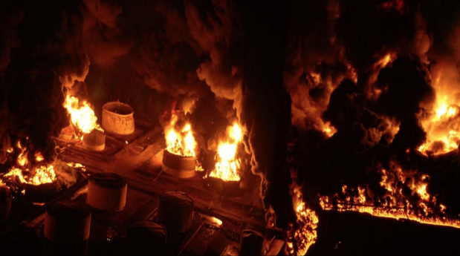
Image: Massive fire at CAPECO facility in Puerto Rico (source: csb.gov)
Caribbean Petroleum Company (CAPECO) Explosion – Material & Energy Balances 1
Problem Statement 2
Incident Information 2
Safety Analysis 3
Calculations 4
Simulation 5
Chemical Hazard Analysis 6
Bow Tie Analysis 6
Reflection 6
Advanced Process Safety Modules 6
Hazard and Operability (HAZOP) Study 6
Layers of Protection Analysis (LOPA) 8
Definitions 10
General Process Safety Definitions 10
Module Specific Definitions for CAPECO Explosion 11
Nomenclature 11

Problem Statement
Safety Module 1: Explosion at Caribbean Petroleum Company (CAPECO), October 23, 2009, in Bayamón, Puerto Rico. Developed in collaboration with Kara Steshetz, University of Michigan and Professor Bryan Goldsmith, University of Michigan.
This incident occurred while gasoline was being unloaded from a tanker vessel. The main storage tank was full, so the flow was diverted to one of two smaller storage tanks. The use of a faulty manual level monitoring system on a storage tank resulted in the overflow, ignition, and explosion of 200,000 gallons of gasoline, culminating in a fire which continued for 2 days. Over 300 homes and businesses were damaged and nearby soil, waterways, and wetlands were contaminated.
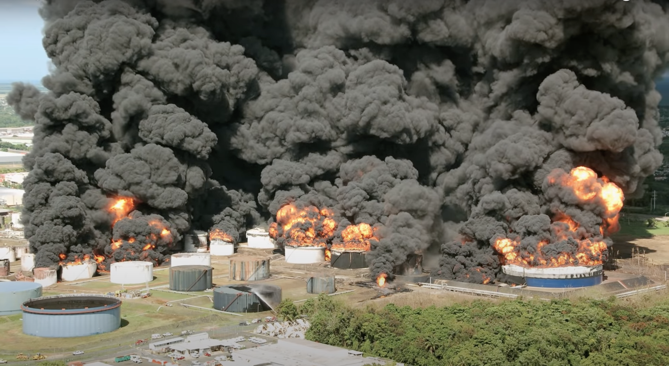
Image: The CAPECO facility engulfed in flames. (source: cbs.gov)

Incident Information
CSB video about CAPECO incident
CSB CAPECO Incident Report pages 9-13 and 25-28

Safety Analysis
It is important that chemical engineers understand what the accident was, why it happened, and how it could have been prevented to ensure similar accidents may be prevented. Performing a safety analysis to the accident will help achieve this goal. In order to become familiar with a strategy for accident awareness and prevention, view the Chemical Safety Board video on the explosion at the Caribbean Petroleum Company and fill out the safety analysis table below. See definitions on the last page. If necessary, view pages 9-13 and 25-28 of the CSB CAPECO incident report.

Criteria | Responses
Activity
Hazard
Incident
Initiating Event
Preventative Actions and Safeguards
Contingency Plan and
Mitigating Actions
Lessons Learned

Calculations
The following calculations connect safety considerations within this module to knowledge learned in this course to help understand how your knowledge can minimize safety issues.

- Plant operators saw a vapor cloud (saturated with gasoline vapor) that was 3 ft. high and covered 107 acres. Determine the concentration in mole % of gasoline in the cloud surrounding the tank. How many moles of gasoline were in the vapor cloud? Note: assume the gasoline is pure octane.

- The upper and lower flammability limits for gasoline are LFL = 1.4 mole % and UFL = 7.6 mole %. Was the cloud gasoline concentration within these limits? Explain.

- How much energy was released by the CAPECO explosion? How much TNT (in US Tons) would be needed to release an equivalent amount of energy given that the molar enthalpy of TNT is -3407 kJ/mol (NIST Chemistry WebBook, Trinitrotoluene)?

Simulation
Answer the following questions using Wolfram siders.
- Download Wolfram CDF Player for free. Instructions on how to install the player can be found on Wolfram’s support page.
  - Instructions for installing on Windows
  - Instructions for installing on MacOS
- Download Wolfram code for this module
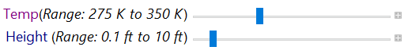
Wolfram sliders

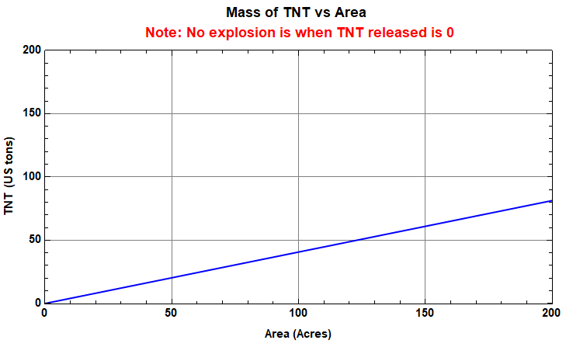
Sample output graph: Energy released in explosion as a function of area covered by gasoline vapor

- Vary the temperature slider to find the temperature range where no explosion would have occurred. The case of “no explosion” is identified at temperatures where energy released is zero for every area and height.

- Estimate the amount of energy released (in US tons of TNT) if the surrounding temperature was 323.15 K at a height of 1 ft and Area of 107 acres.

- Consider a case where the gasoline vapor was restricted to a space of 20 acre and a height of 10 ft. What is the maximum amount of energy that can be released due to the cloud explosion at T = 300 K?

- Vary the sliders and write a set of conclusions based on your experiments in the previous questions.

Chemical Hazard Analysis
Review the information in the NFPA Diamond tutorial. After reviewing the information, visit the CAMEO Chemicals website and fill out the blank NFPA Diamond below for octane.
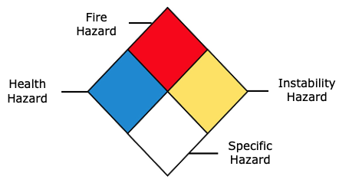
- Fire Hazard:
- Health Hazard:
- Instability Hazard:
- Specific Hazard:

Bow Tie Analysis
Review the Bow Tie diagram tutorial. After reviewing the information, create a Bow Tie diagram for the CAPECO incident.

Reflection
Describe what was the most unsettling to you about the incident.

Advanced Process Safety Modules
The next parts are based on industry practices used to assess process safety and are designed to be used in upper-level courses. For professors interested in assigning these parts now, tutorials for both can be found on the University of Michigan SAFEChE website.

Hazard and Operability (HAZOP) Study
A HAZOP study is a structured analysis of process design to identify potential vulnerabilities in a facility. Review the HAZOP tutorial before completing one for the following system. It is important to note that not all guidewords and parameters will be relevant for different systems. Some information is given here for guidance:
System to consider: Secondary Gasoline Storage Tank 409
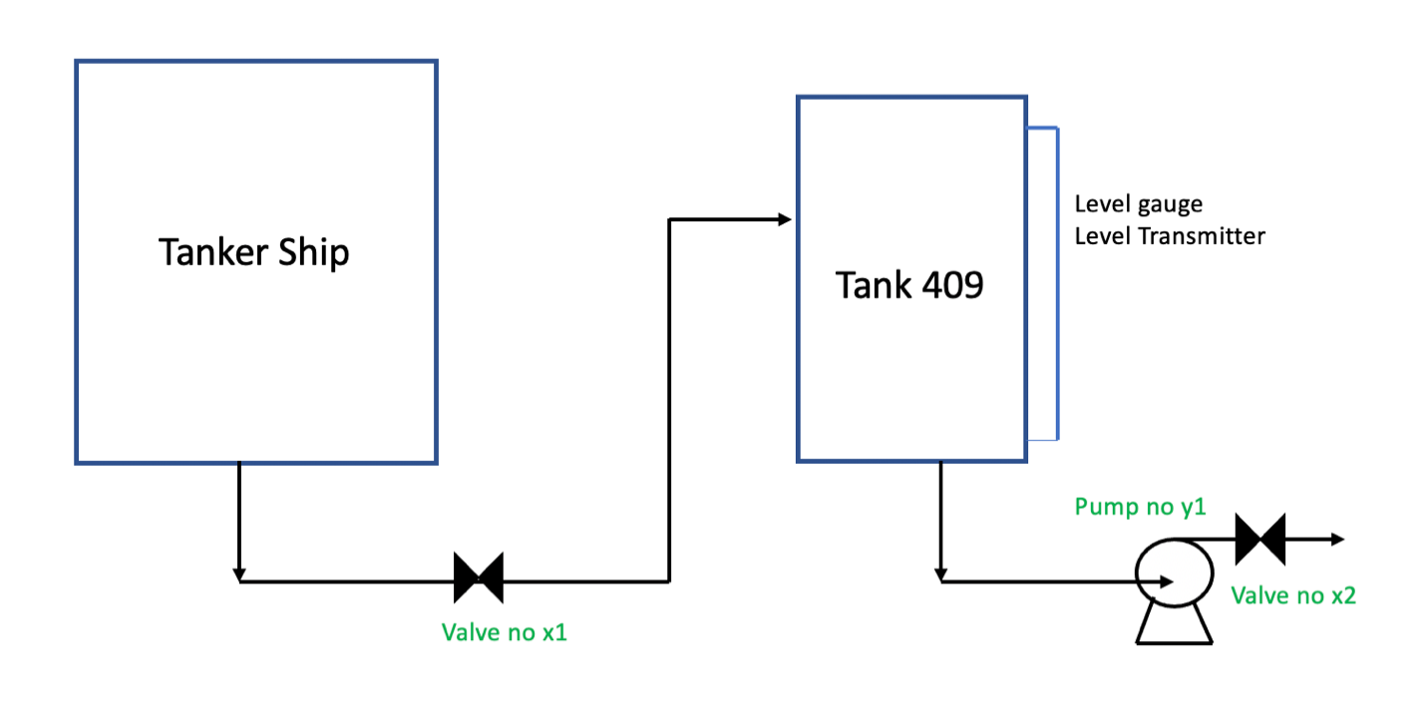
Process parameters to consider: Flow, Level

- Fill out the HAZOP chart below. The first row has been filled out here for you as an example.
Guideword + Parameter = Deviation | Causes | Consequences | Safeguards | Recommendations
No Inlet Flow to Tank 409 | Example: Inlet line valve (x1) full closure due to human error | Example: No flow to Tank 409  - Low level in tank  - pump (y1) damage  - release of flammable material | Example: Standard Operating Procedure | Example:  - Low level alarm  - Pump trip on low
More Inlet Flow to Tank 409
Less Inlet Flow to Tank 409
More Level in Tank 409
Less Level in Tank 409
- Write a short conclusion on some takeaways from completing a HAZOP for this system and recommendations you would make.

Layers of Protection Analysis (LOPA)
A Layers of Protection Analysis (LOPA) is a semi-quantitative study to identify available safeguards and determine if the safeguards sufficiently protect against a given risk. Review the LOPA tutorial before filling the table out for the system described in this module. Some information is given for guidance:
- Assume that the plant can only accept a moderate risk
- Business losses were estimated to be more than $500 Million
LOPA Study for CAPECO Explosion
Initiating Event | Cause: | Operator error leading to miscalculated fill time
 | Consequence: | Gasoline tank overfill leading to vapor cloud explosion
 | Frequency of Initiating Event (FOIE):
Independent Protection Layers (IPLs) | Description of IPL₁, IPL₂ ... | IPL₁- Physical Containment (Dike)
Probability of Failure of IPLs:
PFD = PFD1 x PFD2 x ...
Mitigated consequence frequency (MCF) | MCF = FOIE x PFD
 | Category of MCF:
Severity | Impact: | Business losses of more than $500 million
 | Category:
Risk | Type of risk:
 | Acceptable / Unacceptable?

If risk evaluated above is unacceptable, please continue below:
Proposed IPL(s)  (P-IPL(s)) | Description of P-IPL₁, P-IPL₂, ...
 | P-PFD = P-PFD₁ x P-PFD₂ x ...
MCF | MCF = FOIE x PFD x P-PFD
 | Category of MCF:
Risk | Type of risk:
 | Acceptable / Unacceptable?

Definitions

General Process Safety Definitions
Term | Definition
Activity | The process, situation, or activity for which risk to people, property or the environment is being evaluated.
Hazard | A chemical or physical characteristic that has the potential to cause damage to people, property, or the environment.
Incident | What happened? Description of the event or sum of the events along with the steps that lead to one or more undesirable consequences, such as harm to people, damage to property, harm to the environment, or asset/business losses.
Initiating Event | The event that triggers the incident, (e.g., failure of equipment, instrumentation, human actions, flammable release, etc.). Could also include precursor events, (e.g., no flow from pump, valve closed, inadvertent human action, ignition). The root cause of the sum events in causing the incident.
Preventative Actions and Safeguards | Steps that can be taken to prevent the initiating event from occurring and becoming an incident that causes damage to people, property, or the environment. Brainstorm all problems that could go wrong and then actions that could be taken to prevent them from occurring.
Contingency Plan/ Mitigating Actions | These actions occur after the initiating event. They are steps that reduce or mitigate the incident after the preventative action fails and the initiating event occurred.
Lessons Learned | What we have learned and can pass on to others that can prevent similar incidents from occurring
Bow Tie Diagram | A qualitative hazard analysis tool through which potential problems and consequences associated with a hazard are studied through a pictorial representation. Necessary preventive and mitigating barriers are determined to reduce the process safety risk.
Hazard and Operability Study (HAZOP) | A qualitative hazard analysis tool that uses a set of guide words to determine whether deviations from design or operating intent can lead to undesirable consequences. The existing safeguards are evaluated and if required, actions are recommended to mitigate the consequences.
Layer of Protection Analysis (LOPA) | A semi-quantitative study that determines initiating event frequency, consequence severity, and likelihood of failure of independent protection layers (IPLs) to calculate the risk of a scenario. If the existing risk is intolerable, then additional IPLs are suggested to bring down risk to an acceptable level.

Module Specific Definitions for CAPECO Explosion
Term | Definition
Flammability Limit | Vapor in mixtures will only ignite and burn over a well-specified range of compositions
Lower Flammability Limit (LFL) | The mixture will not burn when the composition is below the lower flammability limit
Upper Flammability Limit (UFL) | The mixture will not be combustible when the composition is too rich and is above the upper flammability limit.
Flash Point | Temperature at which a vapor-air mixture above a liquid is capable of sustaining combustion after ignition from an energy source.

Nomenclature
Symbol | Description | SI Unit
P | Atmospheric pressure | Pa
T or Temp | Surrounding temperature | K
TNT | Trinitrotoluene (an explosive) | ---
y_{sat} | mole fraction of gasoline in vapor cloud assuming vapor cloud is saturated with gasoline vapor | ---

